Complete Student Acknowledgement
- Login to Caesar: https://caesar.ent.northwestern.edu/
- You will see a similar screen in your “Student Homepage”
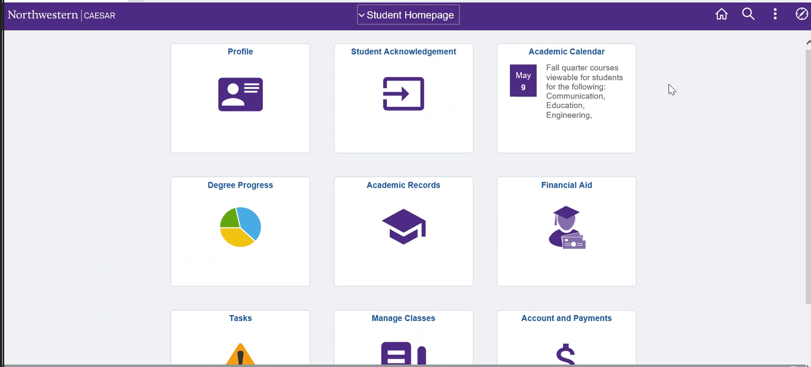
- Click on the “Student Acknowledgement” tile
- A list of holds associated with your account will appear. Click on, the option “Student Acknowledgement” from the list
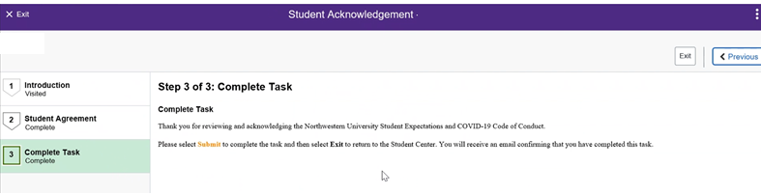
- A new screen will appear with steps of completion:
- Once the task is complete the hold will be removed from your account

