

Live Proctoring

Test-taker Guide

For assistance:
Phone: 1-855-392-6489 (1-855-Examity) or 1-617-500-6524 | Email: support@examity.com | Chat: Live Chat feature on your Examity dashboard
© Examity 2021 | examity.com 08.2021 GENERAL LMS

Table of Contents
Creating Your Profile… 1
Navigating Your Dashboard… 3
Taking Your Exam… 3
How to Use the Examity Sidebar 9
Completing Your Exam… 11

TECHNICAL REQUIREMENTS:
Before your exam, please confirm you meet Examity’s technical requirements.

- Browser: Google Chrome, please disable your pop-up blocker.

- Equipment:
- Desktop, laptop, or Chromebook (tablets are not supported)
- Built-in or external webcam
- Built-in or external microphone
- Built-in or external speakers

- Internet: A required upload and download speed of 2Mbps, with 10Mbps recommended.

Creating Your Profile
The first time you attempt to access Examity, you will be prompted to create your profile. Profile creation is a very quick process.
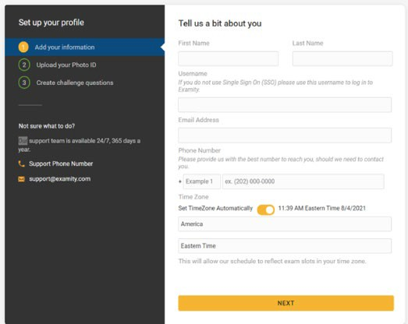
- Provide key contact information for your profile.

TIP: Confirm that your time zone reflects the location in which you will be testing.

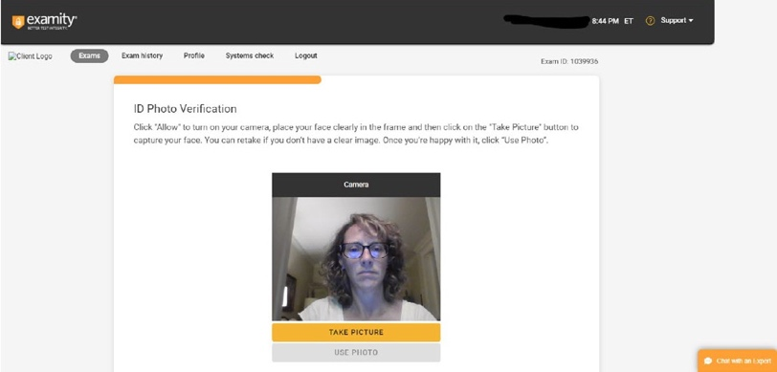
- Upload a picture of yourself or your ID. Please note, for verification purposes, you will need to bring this ID with you every time you take a test.

- Select and answer three challenge questions.
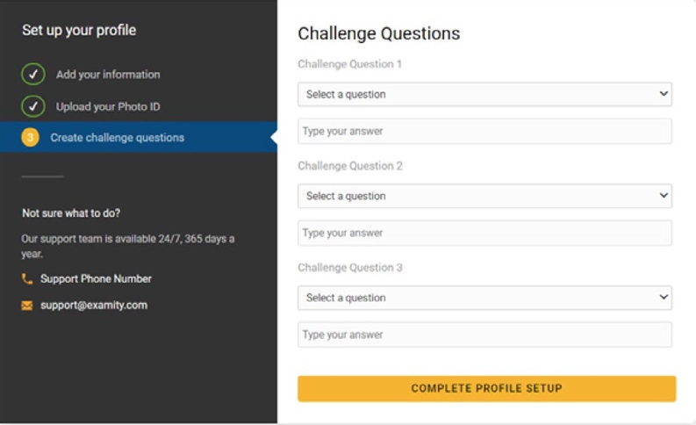
Your profile has now been created. You should see a confirmation screen. Please select “Check if your system meets Examity requirements” before proceeding to the exam dashboard.
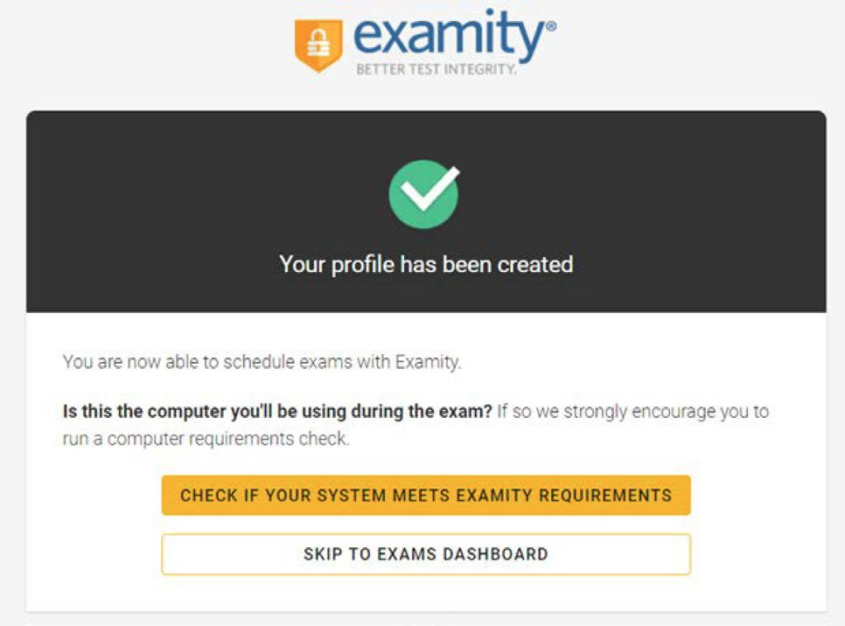

Navigating Your Dashboard
Once your profile is created, you will be directed to the Examity dashboard.
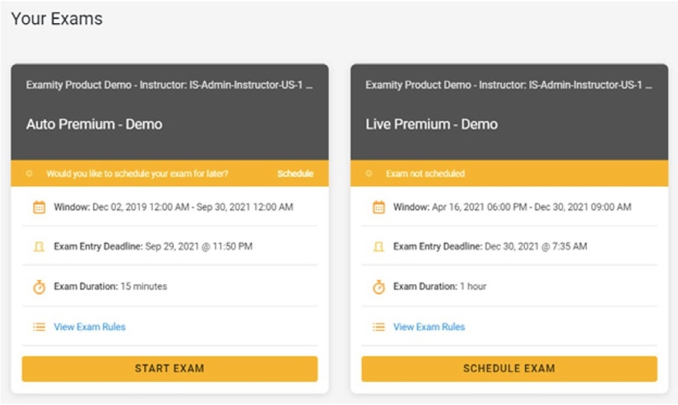
The Examity dashboard is where you will schedule, reschedule, cancel, and start exams. In addition, your dashboard offers access to edit your profile information.

Taking Your Exam
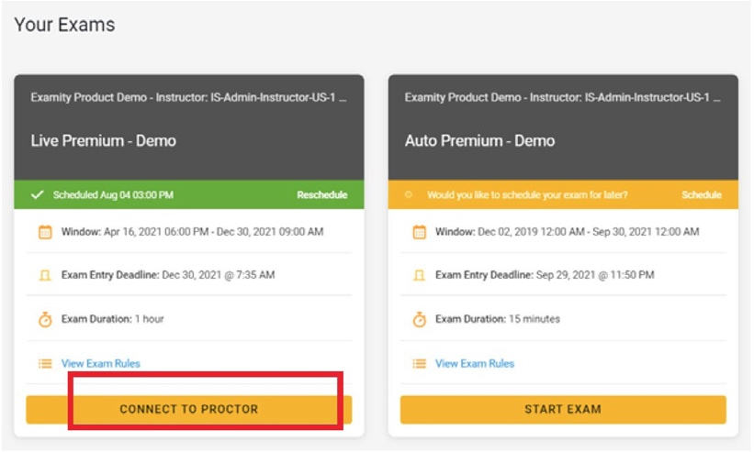
On the day of your exam, locate the exam card and select “Connect to Proctor.”

You will be sent to a new screen where you will be asked to run through a few steps to confirm you meet our technical requirements, verify your identity, and approve our user agreement.

REMINDER: Before you start your exam, please confirm that you are accessing Examity through Chrome. If you are not using this browser, please restart your exam session in Chrome.

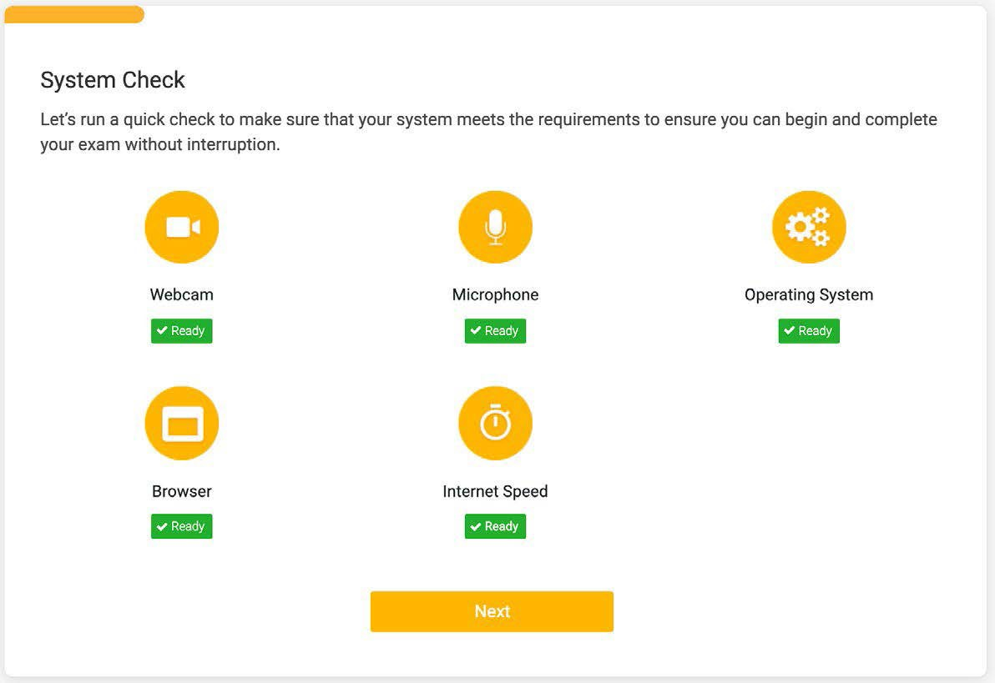
- System Check: Examity will confirm you meet our technical requirements.
- Browser Extension: Please follow the prompts to add the Examity extension to your browser. Then click “Next.”
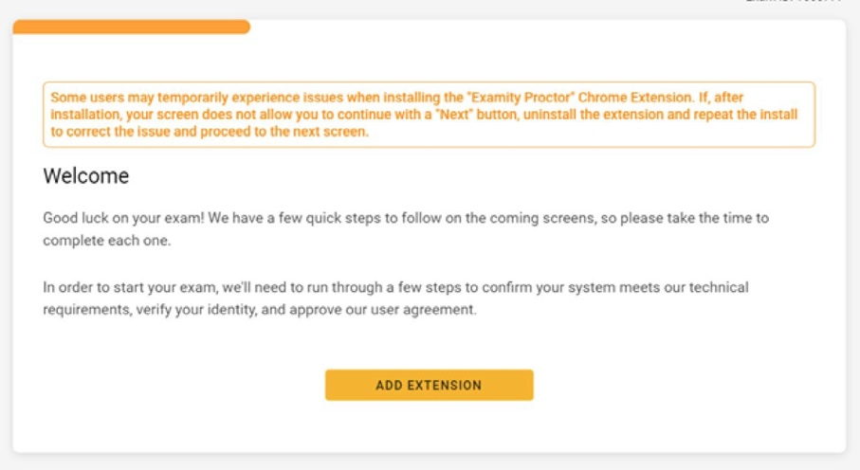

REMINDER: Because we automatically delete the extension at the end of your session, you will need to complete this step every time you test.

- Identity Verification: A pop-up will appear to give Examity access to your camera; please select “Allow.” Once ready, click “Take Picture” and then “Use Photo” to upload an image and continue.
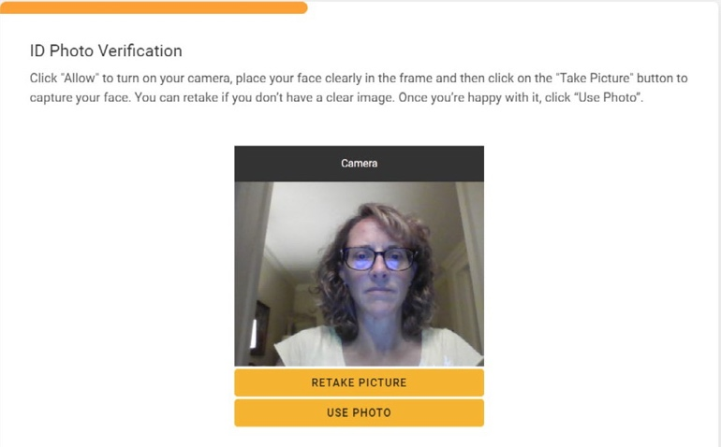

Examity will also prompt you to take a picture of your ID. Please choose “Allow” to give Examity access to your camera. Once ready, click “Take Picture” and then “Accept ID” to upload the image and continue.
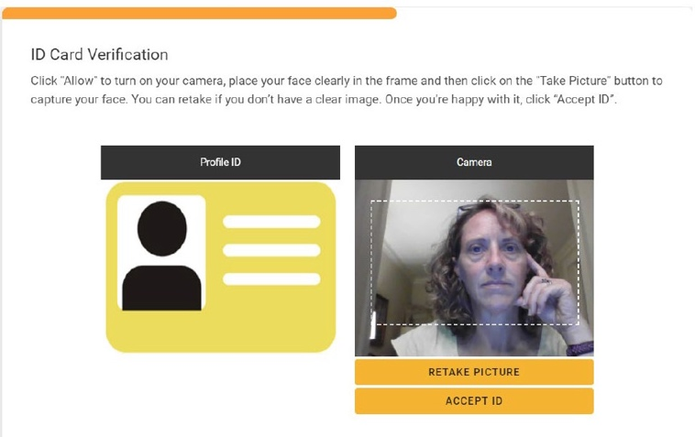

- Challenge Question: Answer a previously selected challenge question. Once you have entered your answer, click “Next.”
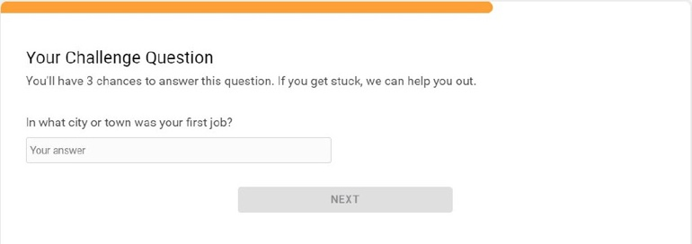

- Review Rules: Take a moment to review all exam rules and special instructions. If your instructor uploaded materials for this exam, you will download them under “Download Exam Support Files.” Then, click “I’m ready.”
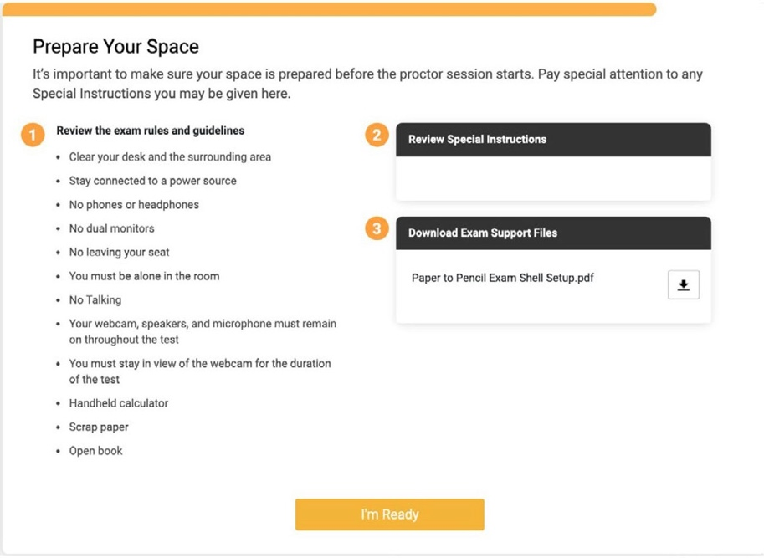

- User Agreement: Next, read and agree to Examity’s user agreement by clicking “I agree and I’m ready to begin the exam.”.
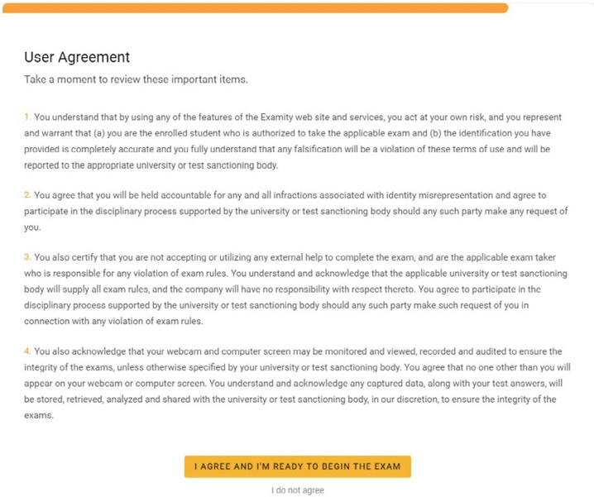

- Share Your Screen and Launch: At this point, you’ll be prompted to share your screen. Select your screen, then click “Share.”
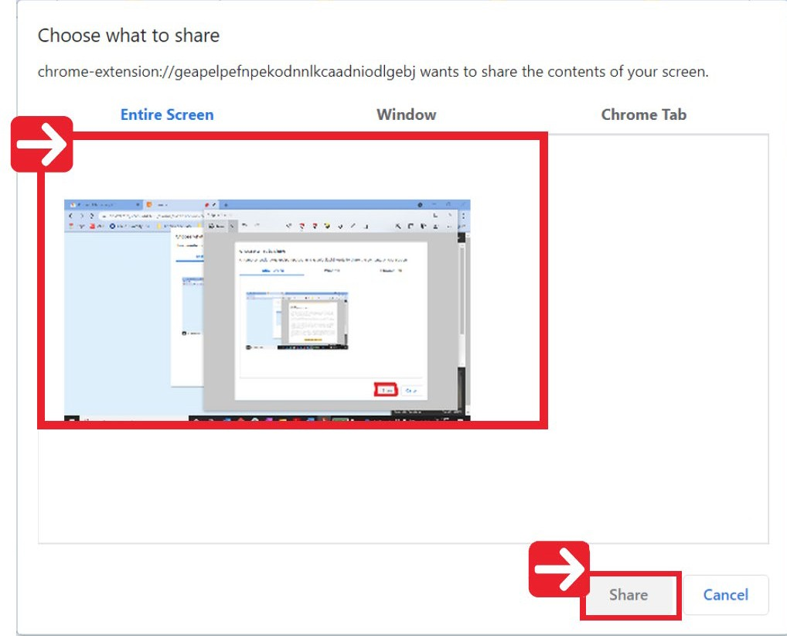
Once you’ve enabled screenshare, click “Launch” and we will take you to the test platform.
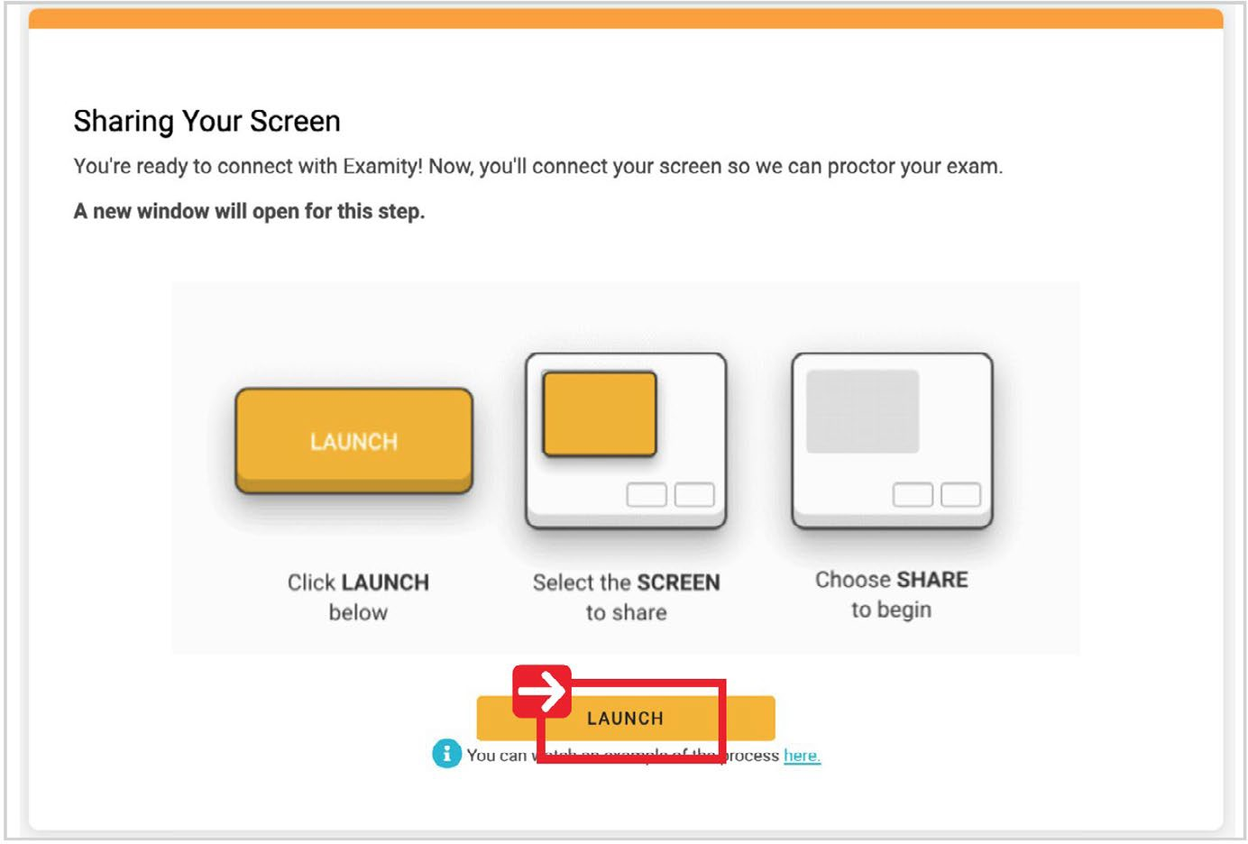

- Connect to Proctor: You will now be connected to a proctor who will walk you through the ID verification process and any instructions to access your exam.
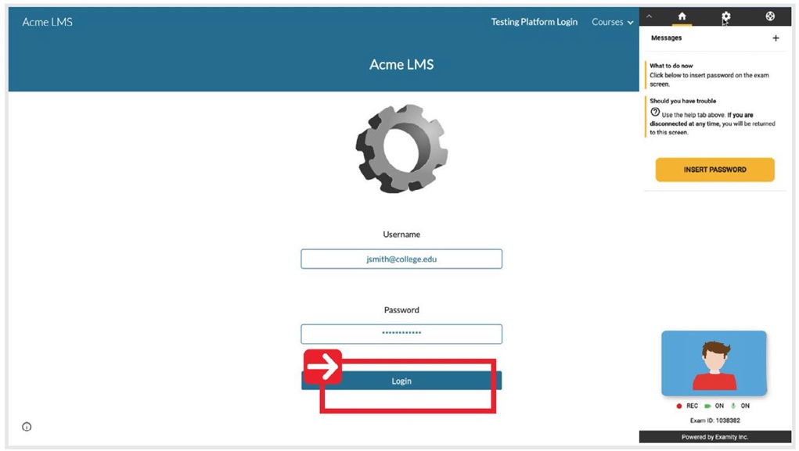
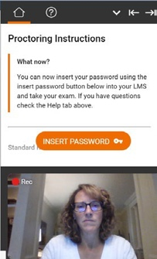

- Insert Password: After authentication and pre-test procedures, your proctor will instruct you to insert the exam password. Simply click “Insert Password” and Examity will automatically fill the exam password. A pop-up box will reconfirm that the password has been entered correctly. If the password does not appear, refresh the page and click “Re-insert your exam password.” You will then click the “Start Exam” button.
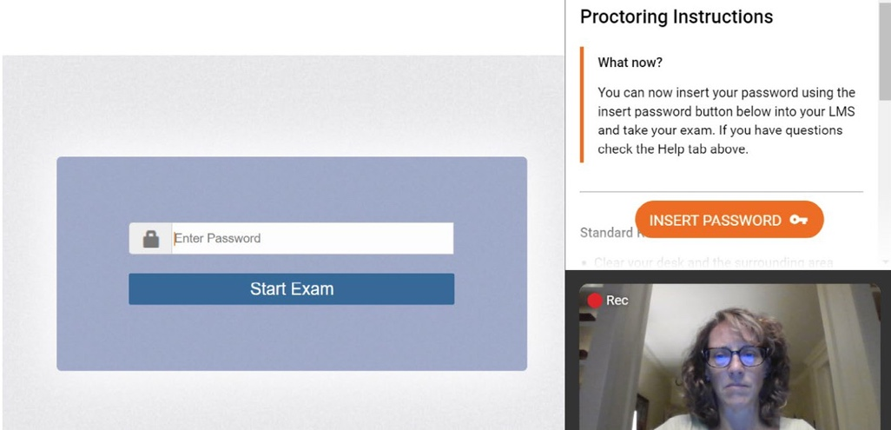

How to Use the Examity Sidebar
The Examity sidebar provides one-click access to everything you need for proctoring, including inserting the password, instructions, rules, and ending your exam.

The Home icon on the left has instructions based on where you are in the proctoring process.
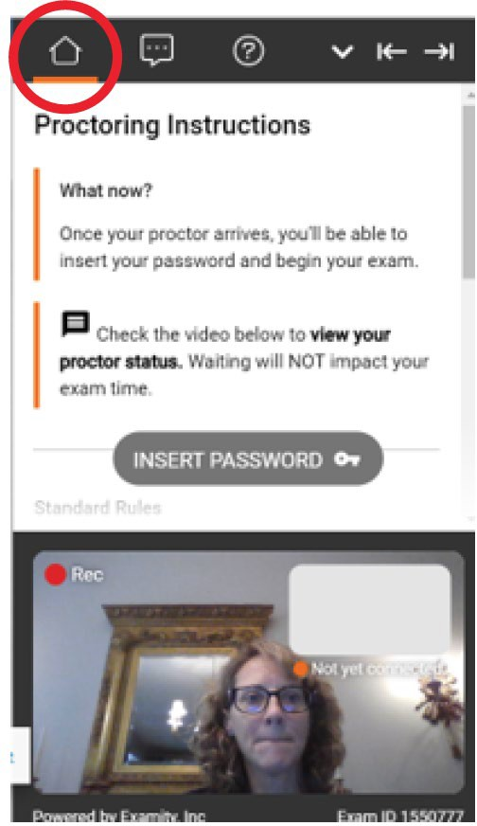

The Chat icon allows you to chat with your proctor.
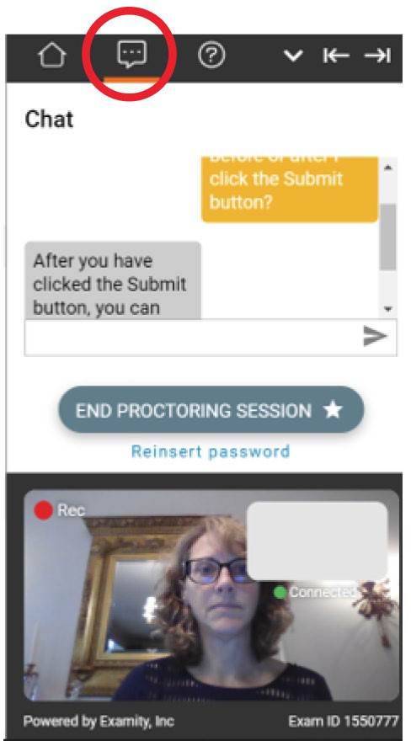

The Help icon will show you the standard rules, additional rules, and special rules. The down arrow will allow you to collapse (and later expand) the Sidebar.
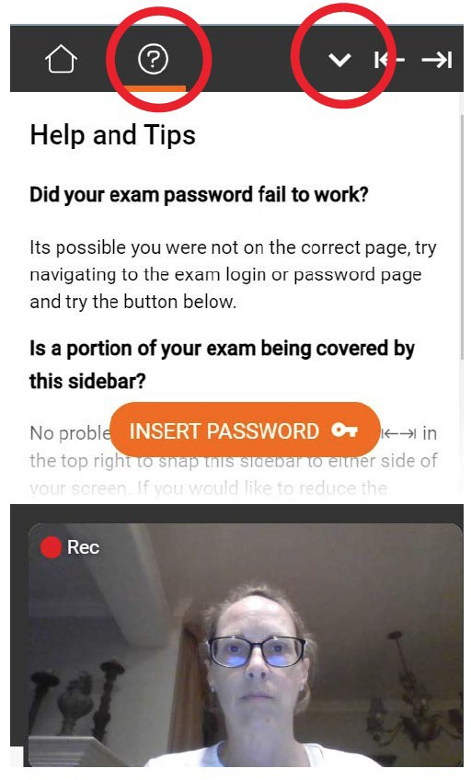
The right and left arrows allow test-takers to place the Sidebar on the left or right of their screen.
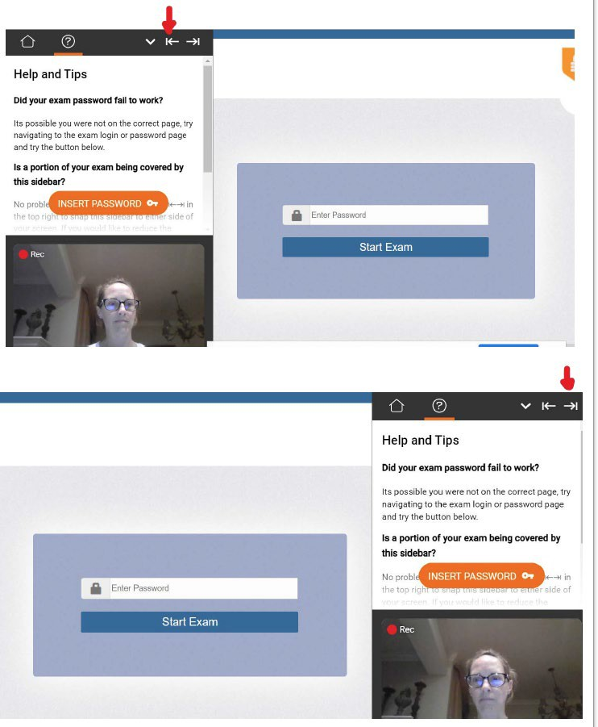

For assistance: 10

Completing Your Exam
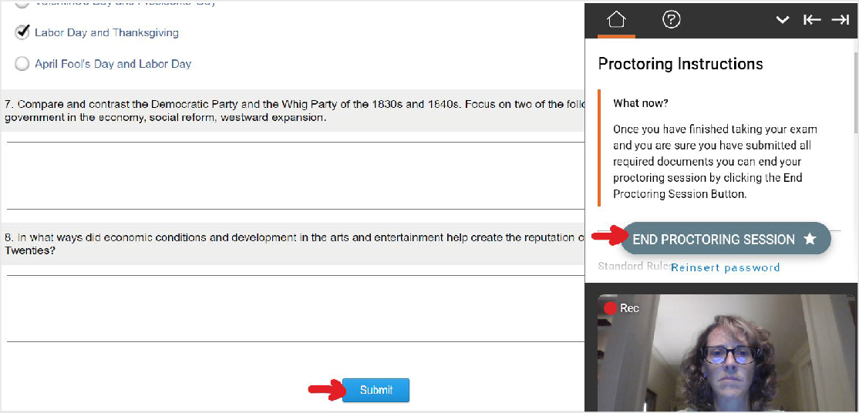
- Submit Your Exam: Once you have completed your exam, notify your proctor and they will walk you through the submission procedure. You will click the Submit button and then click the “End Proctoring Session” button.
- Take a Brief Survey: Your opinion is important to us and we are constantly working to improve. Complete the short survey and then click “Submit.”
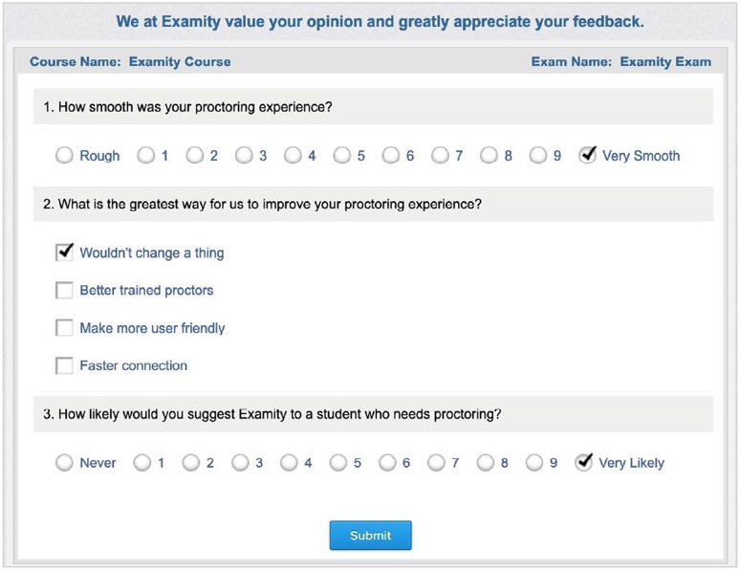

- Close Out Examity: You may now close out of Examity. This will uninstall the Examity extension.

11
For assistance:

